**Read users of Azure AD groups through Github Actions**

**Step 1) Add GitHub repo secrets**

Assuming the Tennant Id has enough access privileges we need to put following as secret in github repo setting.

In your GitHub repo → Settings → Secrets and variables → Actions → New repository secret

* TENANT_ID
* CLIENT_ID
* CLIENT_SECRET

**Step 2) Add the workflow file**

Create .github/workflows/graph-smoke.yml:

name: Graph API Smoke (Client Secret)

on:

workflow_dispatch:

permissions:

contents: read

jobs:

call-graph:

runs-on: ubuntu-latest

steps:

- name: Ensure jq is available

run: |

if ! command -v jq >/dev/null 2>&1; then

sudo apt-get update -y

sudo apt-get install -y jq

fi

- name: Get token (client credentials)

id: tok

run: |

TOKEN=$(curl -s -X POST "https://login.microsoftonline.com/${{ secrets.TENANT_ID }}/oauth2/v2.0/token" \

-H "Content-Type: application/x-www-form-urlencoded" \

-d "client_id=${{ secrets.CLIENT_ID }}&client_secret=${{ secrets.CLIENT_SECRET }}&scope=https%3A%2F%2Fgraph.microsoft.com%2F.default&grant_type=client_credentials" \

| jq -r .access_token)

if [ -z "$TOKEN" ] || [ "$TOKEN" = "null" ]; then

echo "Token fetch failed"; exit 1

fi

echo "token=$TOKEN" >> $GITHUB_OUTPUT

- name: GET sample - list a few groups

run: |

curl -sS -H "Authorization: Bearer ${{ steps.tok.outputs.token }}" \

"https://graph.microsoft.com/v1.0/groups?\$top=5" | jq .

- name: GET all users (paged)

run: |

NEXT="https://graph.microsoft.com/v1.0/users?\$select=id,displayName,userPrincipalName&\$top=999"

: > users.ndjson

while [ -n "$NEXT" ]; do

RESP=$(curl -sS -H "Authorization: Bearer ${{ steps.tok.outputs.token }}" "$NEXT")

echo "$RESP" | jq -c '.value[]' >> users.ndjson

NEXT=$(echo "$RESP" | jq -r '."@odata.nextLink" // empty')

done

jq -s '{value: .}' users.ndjson > users.json

echo "Total users: $(wc -l < users.ndjson))"

head -n 5 users.ndjson | jq .

- name: Upload full users list

uses: actions/upload-artifact@v4

with:

name: all-users

path: users.json

- name: Quick user count (sanity)

run: |

curl -sS -H "Authorization: Bearer ${{ steps.tok.outputs.token }}" \

-H "ConsistencyLevel: eventual" \

"https://graph.microsoft.com/v1.0/users?\$count=true&\$top=1" | jq '."@odata.count"'

**Step 3) Run workflow**

**All user list**

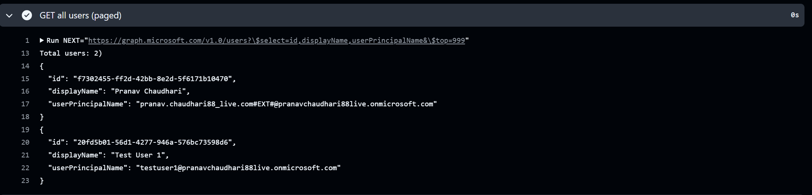

**All user count**

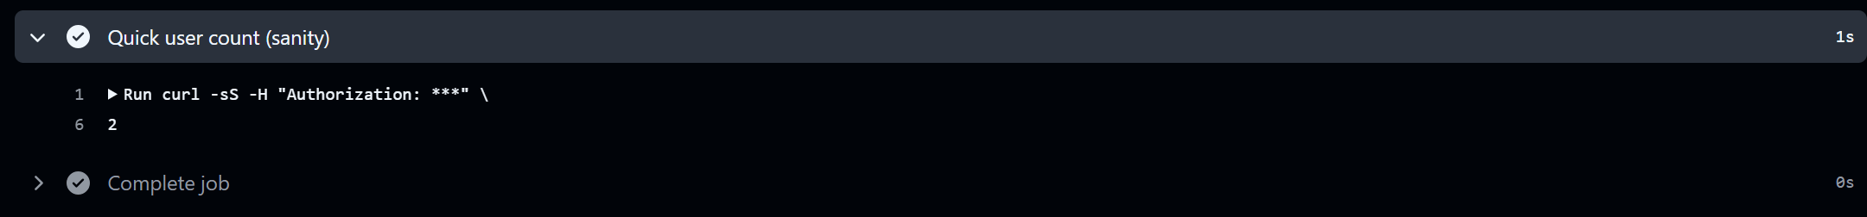

With Microsoft Graph + GitHub Actions workflow, we can both read and change Azure AD objects.